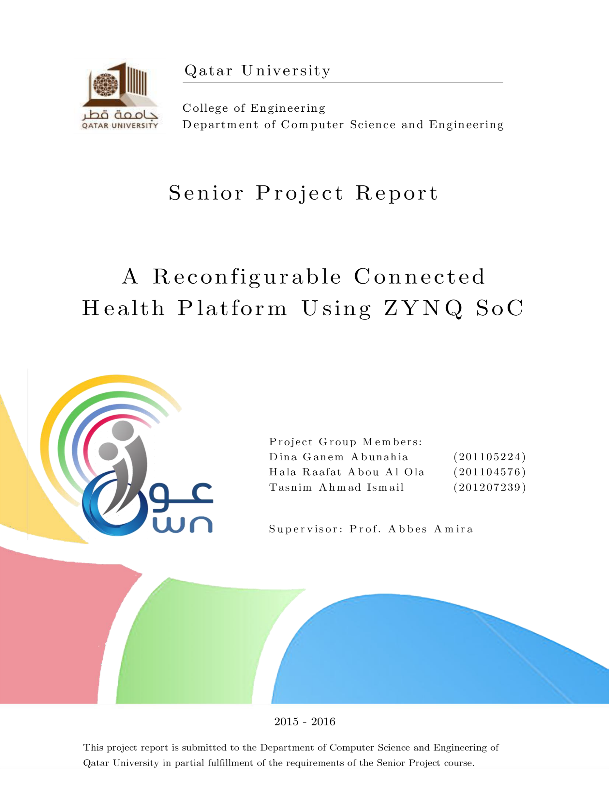

# Declaration

This report has not been submitted for any other degree at this or any other University. It is solely the work of us except where cited in the text or the Acknowledgements page. It describes work carried out by us for the capstone design project. We are aware of the university’s policy on plagiarism and the associated penalties, and we declare that this report is the product of our own work.

Student: Dina Ganem Abunahia Date: 24th May 2016

Signature:

Student: Hala Rafat Abou Al Ola Date: 24th May 2016

Signature:

Student: Tasnim Ahmad Ismail Date: 24th May 2016

Signature:

# Abstract

Qatar aims to develop integrated systems for health care, managed according to world-class standards to improve the health of Qatar’s population. This project aims to provide users and their families with a sense of mental and physical security in their houses, at a reasonable cost, hence providing a significant socioeconomic impact. The project aims to develop a reconfigurable connected health platform for fall detection and electrocardiogram (ECG) analysis using the Shimmer sensing device and ZYNQ system on chip (SoC) platform. The proposed solution can be employed in a smart home environments to equip them with real-time health monitoring technologies. Furthermore, it aims to develop new pattern recognition, fusion and classification algorithms for automatic fall detection and ECG analysis. The proposed system is designed to be used by elderly, diabetics, muscular patients, and neurological patients who are likely to fall, in addition to patients with cardiovascular problems who have higher probabilities to get heart attacks causing falls. This solution has three main features: (1) Sensing data gathered from the accelerometer and ECG electrodes embedded in the Shimmer sensing device; (2) Real-time monitoring and alerting system on the Zynq SoC board; (3) Medical logging consisting of time and position of the fall, as well as the ECG signal and features extracted. Data processing and analysis are performed through the machine learning algorithm K-nearest neighbor (KNN) for fall detection. This algorithm is implemented in the programmable logic (PL) part of the Zynq. Other algorithms responsible for the ECG analysis and processing can be implemented using the processing system (PS) on the ZYNQ SoC using a hardware software co-design approach. The database used to assist the accuracy of the system was collected from twelve people with eight scenarios. The real-time classification of the fall detection has been achieved with an accuracy of 96.602%. Moreover, the hardware implementation of the KNN requires only an average execution time of 131 micro second and an average detection time of 5.052 seconds.

# Acknowledgment

This project would not have been accomplished without the help and guidance of Allah, who gave us the strength to go on when we were willing to drop everything. Then, we would like to express our deep appreciation to our supervisor Professor Abbes Amira who directed and motivated us, to work, and to believe in ourselves that we can make it happen, he provided us with the technical and emotional help we needed throughout our graduating journey. Finally, we sincerely thank our parents and families, who were supporting and encouraging us in our undergraduate degree journey, cheering us up and standing by us through good and bad.

Table of Contents

Declaration 2

Abstract 3

Acknowledgment 4

List of Figures 8

List of Tables 10

List of Equations 10

Abbreviations 12

Glossary 14

1. Introduction and Motivation 15

1.1. Problem Statement 15

1.2. Project Significance 16

1.3. Project Objectives 20

1.4 Contributions 21

1.5 Structure of the Report 21

2. Background and Related Work 22

2.1. Background 22

2.1.1. Tri-Axial Acceleration 22

2.1.2. Bluetooth 22

2.1.3. Electrocardiogram (ECG) 23

2.1.3. Encryption of Electronic Protected Health Information (ePHI) 24

2.2 Related work 25

2.2.1 Technologies for Connected Health Applications 25

2.2.2 Fall Detection Using Various Technologies 25

2.2.3 ECG Acquisition and Analysis 31

2.2.4 FPGA device based connected health systems 32

2.2.5 Using Classification Algorithms with Medical Datasets 35

3. Requirements Analysis 37

3.1. Functional Requirements 37

3.2. Design Constraints 39

3.3. Design Standards 40

3.4. Professional Code of Ethics 41

3.5. Assumptions 44

4. Detailed Design 45

4.1. Overview 45

4.2. High-Level Architecture 45

4.3. Hardware Design 46

4.3.1. Shimmer Platform 46

4.3.2. Zynq SoC Prototyping Board 49

4.3.3. PmodBT2 Bluetooth module 55

4.4. Software Design 56

4.4.1. Overview of Used Software: LabVIEW 56

4.4.2. Overview of Used Software: Vivado and Xilinx SDK 56

4.5. Discussion of How Design Constraints Were Met 57

4.5.1. Technical Design Constraints 57

4.5.2. Practical Design Constraints 58

5. Implementation 60

5.1. Solution Overview 60

5.2. Software Implementation on the PC 62

5.2.2. Falling Detection Implementation 62

5.2.3. ECG Analysis Implementation 68

5.2.4. Alerting System 76

5.3. KNN Implementation on the Zynq SoC boards 78

5.3.1. Hardware/Software Partitioning 78

5.3.2. KNN Implementation on the Zedboard: Vivado HLS 79

5.3.3. KNN Implementation on the myRIO board 83

6. Testing 94

6.1. Software Test 94

6.1.1. Testing the KNN Algorithm 94

6.1.2. Testing the Email Service 97

6.1.3. Testing the ECG acquisition and analysis 98

6.2. Hardware Test 99

6.2.1. Analysis Metrics 99

6.2.2. Testing KNN Algorithm 99

6.3. Overall System Evaluation 104

6.4. Design Constraints Evaluation 105

6.5. Evaluation of the impact of the engineered solution 106

6.6. System Weakness/Strength 107

7. Project plan 108

7.1. Project Milestones 108

7.2. Project Timeline 110

7.2.1. Project Timeline of Senior Design Project I 110

7.2.2. Project Timeline for Senior Design Project II 112

7.3. Anticipated Risks 113

8. Delivery 114

8.1. Real-world deployment scenarios 114

8.2. Commercialization potential and opportunities 114

9. Conclusion 115

10. Future Work 116

11. Students Reflection 117

References 119

# List of Figures

Figure 1 Statistics of falls, diabetes mellitus, and coronary heart diseases in Qatar during the year 2014 16

Figure 2 Bluetooth topology with piconet structure 23

Figure 3 Basic electrophysiology of the heart [12] 24

Figure 4 Classification of falling detection method [15] 26

Figure 5 Schematic representation of the working principle of the floor vibration based falling detector [21] 28

Figure 6 Framework for existing ambiance based approaches [15] 29

Figure 7 Coordinate and gravity before and after falling. (a) Before falling (b) After falling [22] 30

Figure 8 Android smartphone attached to the waist [25] 31

Figure 9 Sample frames captured during a fall from standing up position [25] 31

Figure 10 Survey on fall detection using various technologies 32

Figure 11 Hardware System Diagram[27] 33

Figure 12 Survey on ECG acquisition and analysis systems 35

Figure 13 Survey on fall detection on Heterogeneous Systems 36

Figure 14 System use case diagram 39

Figure 15 High-level architecture 47

Figure 16 Internal and external views of Shimmer 49

Figure 17 Shimmer.vi as a state machine 50

Figure 18 Upper view of the Zedboard [37] 52

Figure 19 Zedboard hardware block diagram [37] 53

Figure 20 Front view of the NI MyRIO enclosed device [39] 54

Figure 21 Upper view of the NI MyRIO inner board [39] 54

Figure 22 NI myRIO hardware block diagram [39] 55

Figure 23 NI MyRIO design flow 57

Figure 24 Xilinx Zedboard design flow 57

Figure 25 PmodBT2 module [40] 58

Figure 26 Summary of the design flow using NI myRIO 59

Figure 27 Summary of the design flow using the Zedboard 60

Figure 28 System flowchart 64

Figure 29 System setup 65

Figure 30 Acquired acceleration signals for various direction of fall and ADL 67

Figure 31 Orientation of x, y and z-axes in Shimmer sensor 70

Figure 32 LabVIEW code used to detect the fall direction 70

Figure 33 Flowchart of fall direction detection using the value of z-axis 71

Figure 34 ECG acquisition and processing system overview 72

Figure 35 ECG unit simplified block diagram [41] 73

Figure 36 Example positioning of the electrodes for ECG measurement [41] 74

Figure 37 ECG signal preprocessing for R waves detection 76

Figure 38 Heart rate calculated result 77

Figure 39 original ECG signal before encryption and transmission 78

Figure 40 retrieved ECG signal after decryption 78

Figure 41 Alerting system design flow 80

Figure 42 Alerting system user view on tablet 81

Figure 43 Design flow of the Zedboard 83

Figure 44 Hardware block design of the implemented solution 84

Figure 45 Chip layout for K = 3 and a training percentage = 30% 86

Figure 46 Shared Variable Network Sack 87

Figure 47 LogosXT transmission algorithm components 87

Figure 48 System implementation using WiFi and Bluetooth 88

Figure 49 myRio and PmodBT2 interfacing wired diagram (a) hardware connection (b) schematics 89

Figure 50 Bluetooth configuration in PuTTY to establish serial connection between the Bluetooth module and the PC 90

Figure 51 VISA serial configuration to receive data using the Bluetooth module connected to the myRio 91

Figure 52 Shimmer btStream firmware packet format 91

Figure 53 FPGA architecture and resources allocation 92

Figure 54 Zynq SoC fingerprint showing LUTs allocation 93

Figure 55 Assignment of logical LUTs to physical locations (CLBs) 94

Figure 56 FPGA Design Flowchart on LabVIEW 95

Figure 57 System user interface when the user is in normal condition 98

Figure 58 Acceleration signals when the user is in normal condition 99

Figure 59 System user interface when a fall occurs 99

Figure 60 Acceleration signals when the user fall 100

Figure 61 The email sent when a fall occurs 100

Figure 62 ECG signal plotting and features extracting system 101

# List of Tables

Table 1 Summary comparison between various falling detection approaches 31

Table 2 Use cases description 39

Table 3 Technical design constraints 41

Table 4 Practical design constraints 41

Table 5 Design standards 42

Table 6 Professional code of ethics 43

Table 7 Comparison between Zynq SoC prototyping boards; Zedboard and NI-myRio 55

Table 8 Discussion of how technical design constraints were met 60

Table 9 Discussion of how practical design constraints were met 61

Table 10 Accuracy results of testing the algorithm with different values of k and different training percentages 69

Table 11 Implementation report in terms of resources and time consumption 84

Table 12 Implementation report for solution 3 85

Table 13 Power consumption report for solution 3 85

Table 14 Optimization techniques available for the FPGA implementation on NI myRIO 93

Table 15 FPGA resources usage before optimization 96

Table 16 FPGA resources usage after optimization 96

Table 17 Execution time report 102

Table 18 KNN algorithm detection time (in seconds) 103

Table 19 KNN algorithm detection accuracy 104

Table 20 Design constraints evaluation 107

Table 21 Impact of the engineered solution 108

Table 22 Project milestone 109

Table 23 Project timeline and work distribution among team members for SDP I 112

Table 24 Project timeline and work distribution among team members for SDP II 114

# List of Equations

**(Equation 1)** 66

(Equation 2) 68

(Equation 3) 68

(Equation 4) 68

Equation 5 102

Equation 6 102

Equation 7 102

# Abbreviations

3D Three dimensions

ADL Activities of daily life

AES Advanced Encryption Standard

ASIC Application Specific Integrated Circuit

ASSP Application Specific Standard Product

AXI Advanced eXtendable Interface

BPM Beats Per Minute

COM Communication port

CVD Cardiovascular Disease

DDR Double data rate

DIP switch dual in-line package switch

DT Decision Tree

FMC FPGA Mezzanine Card

FPGA Field-Programmable Gate array

GCC Gulf Cooperation Council

GPIO General Purpose Input/Output

GPU Graphical processing unit

HDMI High-Definition Multimedia Interface

HLS High-level synthesis tool

HMC Hamad Medical Cooperation

HR Heart Rate

IO Input/Output

IP Intellectual Property

KNN K-nearest neighbor

LED Light Emitting Diodes

LSM Least Squares Method

MIO Multiplexed Input/Output

MLP Multi-Layer Perceptions

NB Naïve Bayes

OpenCV Open Source Computer Vision

OS Operating System

PC Personal Computer

PCB Printed Circuit Board

PL Programmable Logic

PS Processing System

QCRI Qatar Computing Research Institution

SCH Supreme Council of Health

SoC System-on-chip

TEO Teager Energy Operator

USB Universal Serial Bus

VGA Video Graphics Array

VI Virtual Instrument [refers to LabVIEW program/subroutine]

# Glossary

|  |  |
| --- | --- |
| Depolarization | Electrical activation of the myocardium |
| Repolarization | Restoration of the electrical potential of the myocardial cell. |
| P wave: | ECG deflection representing atrial depolarization. |
| QRS Complex: | ECG deflection representing ventricular depolarization. |
| T Wave: | ECG deflection representing ventricular repolarization. |

# Introduction and Motivation

## Problem Statement

Life expectancy is increasing worldwide as countries have made great contributions to improving the levels of sanitation, housing, and education causing a solid decline in the early mid-life mortality, according to the Institution of Health Metrics and Evaluation. Statistics from the UN World Health Organization show that in the year 2050, the percentage of elderly will keep increasing to reach as much as twice the percentage of children (32% versus 16%). As a result of this quick growth, the demand for medical attention is increasing accordingly. However, why? About one-third of the more elderly population over the age of 65 falls each year, and the risk of falls increases proportionately with age.  Elderly tend to fall more likely than other age groups due to some reasons: 1) Cerebrum degeneration or some diseases causing step imbalance; 2) Side effects of taking medications for people with chronic illnesses might cause dizziness and slow movements; 3) Health problems that might cause people to faint temporarily; 4) Poor lighting environments, slippery floors, and objects in the way of movement. All these factors cause elderly to fall more frequently [1], resulting in serious injuries, and in some situations, it may cause death [2]. Other groups require special attention such as Diabetics, who are likely to get low blood glucose causing fainting, spinal muscular atrophy patients who have movement inconsistency, neurological patients, like Parkinson’s patients who suffer from imprecise movement, and cardiovascular patients who can have heart attacks and collapses. Figure 1 illustrates WHO data statistics about falls, diabetes mellitus, and coronary heart diseases in Qatar during 2014.

Figure 1 Statistics of falls, diabetes mellitus, and coronary heart diseases in Qatar during the year 2014

To prevent such risks, medical care must be provided. However, the shortage of qualified personnel is a common problem. For this reason, this project aims to develop an intelligent system for detecting abnormalities such as sudden falls. The system will keep monitoring the user’s condition all the time, and if an abnormality occurs, an alerting system will notify the health caregivers about the user’s situation to provide immediate assistance.

Qatar’s health statement for 2015 for the E-Health program:  **“to improve overall health in Qatar and deliver healthcare of the highest standard by providing the public, patients, and clinicians with appropriate and timely information”**. From that vision, some objectives were put to deliver health services with the capabilities of modern information technologies. These objectives include:

* **Support the patient** and the delivery of services designed around the patient, quickly, conveniently and seamlessly.
* **Support staff** through effective electronic communications, better learning, knowledge, and management that cut time to find essential information and make specialized expertise more accessible.

## Project Significance

**Importance of the project**

This project aims to provide users and their families with a sense of mental and physical security in their favorite and most comfortable place to be in; home. It will also help them pass through the obstruction of money since they will not need costly home care nursing services. Also, they will enjoy relief without having an observer. As a result, this project provides a significant socio-economic impact such that it focuses on society’s well-being, considering the economic obstacles, using a device with reasonable initial, and lifetime costs. This project goes along with Qatar vision 2030 to build a healthy society. According to the Global AgeWatch Index 2015, the GCC region’s over 60-year-old population percentage is predicted to rise significantly from 0-9% in 2015 to 20-24% in 2050 [3]. This rapid change moved scientists’ and engineers’ interest to elderly as a group of study over the past few years. Likewise, as a result of unhealthy modern lifestyle, the percentages of diabetics and cardiovascular patients have significantly increased. Therefore as engineers, students believe that this project will allow medical care to track critical physiological signs at low cost, with reduced human labor, and in real time. These signs include users’ falls and ECG features that are detected by first developing new recognition pattern and classification algorithms for detecting and preventing falls. Also, the system monitors and analyzes ECG signal to extract critical features that are used for diagnosis. Then it reports information about the direction of the falls, as well as the condition of the user him/herself. On the other hand, the system contains algorithms to acquire and process ECG signals, then transfer the extracted information as a medical log to the medical care providers, when an abnormality is detected.

**Impact of not having a solution to this problem**

There are several reasons why the elderly fall more frequently than other age groups. First, elderlies are likely to be diagnosed with muscle disorders that result in complications, including frequent falling that could cause death [4]. Also, as the body gets older, it is more likely to get harmful side effects when taking medications, such that one in six adults of age 65 and above experiences injurious reactions to medicines, which frequently cause low blood pressure, somnolence, and dizziness [5]. Additionally, other environment factors such as unfamiliar environment, slick floors, and poor lighting can also result in falling. Elderly falls lead to more medical complications including accompanying bone fractures, longer hospital healthcare, and rehabilitation stay, more chances to have surgeries, and they may even result in increasing elder’s mortality [6]. This implies for diabetics, muscular patients, and heart patients who may lose their sense of security with the growth of fear of falling, in addition to losing their dependency and self-confidence, resulting in seeing themselves as a burden on people. Early falling detection would help in reducing the time between falling accident, and the arrival of medical assistance, which will certainly reduce falling consequences. On the other hand, by analyzing ECG signals and send them to the healthcare providers when a fall occurs; the healthcare providers get assistance to diagnose the cause of fall. Thus, the diseases complications will be reduced.

**Outcome of this project and its effects on the stakeholders**

The outcome of this project is to deliver a complete reconfigurable system on a chip, which is capable of distinguishing falls from daily life activities, and giving detailed logs about the orientation of falls, and the condition of the patient. Moreover, the system analyzes the ECG signals and attach them to the medical log to provide further information about the user’s condition. Also, the system may be extended further to detect and diagnose heart abnormalities and diseases, then report them in real time. This project will influence users and their families to provide them with a better quality of living and better healthcare services. Furthermore, it is expected to influence healthcare givers by easing their job and accelerating their response to emergency cases, and hence saving lives. Finally, this project represents a topic of study for researchers in the fields of biomedical and connected health especially that the system is reconfigurable, thus is a subject of scalability.

**Why was this project chosen?**

On the word of Merriam-Webster in the Collegiate Dictionary, engineering is defined as: “the application of science and mathematics by which the properties of matter and the source of energy in nature are made useful to people”. Such that engineers take intellectual ideas, together with the knowledge of mathematics and science to build products that meet the needs of humankind and make their lives easier. From this fact, students sensed the duty of helping these enlarging age groups overcome their daily struggle and the pain of falling complications, also helping them rebuild self-esteem, and independence, without risking their health. The idea of making a difference in people’s lives was the source of students interest in this project, especially that this slice of the society merits efforts to make its life easier. On the other hand, being exposed to biomedical research and projects is a new challenge and a great experience to add before graduation.

**What are the anticipated benefits of this project in Qatar and the region?**

The GCC region has a life expectancy of 75-80 years for female, while it is between 70-75 years for a male between the years 2015 and 2020 [7]. On the other hand, the growth rate in elderlies aged over 65 years increased from 0.9% in 2015 to 29.1% in 2050 of the total population. These statistics confirm the importance of deploying technologies in the field of elderly healthcare and smart house technologies in the region. Also, diabetes and heart diseases have increased significantly according to WHO, and this system will protect them from different fall incidents risks. Moreover, the project will contribute to achieving Qatar National Research Strategy’s vision of making Qatar a foremost center for research, development, and innovation [8]. Also, it will contribute to Qatar University’s Research Strategic Plan to make Qatar University a model undergraduate teaching institute, characterized by its discriminative scholarly efforts [9], and Qatar National Vision 2030 of providing a world-class healthcare system based on high-quality research to improve the effectiveness and quality of healthcare [10].

Additionally, this project is done in collaboration with Hamad Medical Cooperation (HMC) Ambulance Service. Dr. Gilliam Allinier, the director of research, is particularly interested in equipping their ambulances with smart solutions for real-time monitoring and data analysis. Also, Dr. Mark O’Connor, the associate medical director of HMC mobile healthcare service showed interest in remote monitoring solutions at home, and specifically; fall detection.

**How will this project help us further in our career goals?**

Senior design project aims to understand all aspects of student's major better and reflect knowledge, experience, and skills they learned during their 4-5 years in college into a complete design, then implement it into a stand-alone system to be used as a real world application. This is done gradually starting from identifying a problem and approaches to find a solution, to building the design from scratch while overcoming design constraints and various challenges, to solve that problem eventually. This allows students to experience different obstacles and difficulties like teamwork, time management, cost limits, availability of resources, respecting the code of ethics, decision making, and developing their ideas. The complete process prepares students to enter the job market and equips them with the power of knowledge, interaction and awareness abilities, and self-esteem. Also, it enhances writing, design, research, and hands-on skills for students to enable them achieve their career goals and excel in them. Particularly, this project introduces two new fields for computer engineering students, which are biomedical engineering and embedded systems. As a result, students are expected to gain research and self-learning skills to explore these fields and technical expertise regarding implementing a multidisciplinary project. These capabilities and knowledge will eventually open doors for students to work in several medical cooperate in Qatar, such as QCRI, HMS, and SIDRA research center, or any medical research institute abroad.

## Project Objectives

The main aim of this project is to develop a remote monitoring platform that is capable of data processing and analyzing, data storage, and security using tri-axial acceleration signals and ECG signals. Those objectives can be summarized as follows:

* To develop an efficient and intelligent fall detection and ECG processing system using Bluetooth connectivity through acquiring the essential data using a wireless medical sensing platform connected to the Zynq SoC board;
* To monitor the acquired acceleration and ECG data and stream them in real-time;
* To develop new pattern recognition, fusion and classification algorithms for automatic fall detection and ECG analysis;
* To design and implement the proposed algorithms on the NI-myRio equipped with the Zynq SoC platform;
* To evaluate the FPGA implementation of the proposed system in terms of area consumption, resource usage, and timing constraints; and
* To provide a framework that contributes to achieving Qatar’s vision about connected healthcare delivery.

## 1.4 Contributions

The overall project focus and objectives mentioned in sections 1.1 to 1.3 together lead to the project contribution referred to in this chapter.

* The developed system contributes to remote wireless medical health research and application which will be achieved by eliminating the use of a local host and support direct communication between the two system basis; the Shimmer sensing device and the myRIO prototyping board;
* The proposed solution implements the machine learning algorithm, K-nearest neighbor, for data classification and event detection. The algorithm is implemented on the FPGA partition of the Zynq SoC inside the myRIO;
* The solution implements a fall detection and ECG processing reconfigurable platform that employs a hardware/software co-design approach to partition the code between the programmable logic, and the processor system of the Zynq SoC; and
* The system guarantees security by deploying existing advanced encryption standard solution during ECG signals transmission.

## 1.5 Structure of the Report

The report is divided into eleven sections as follows: Section 2 reviews and refers to the existing technologies for fall detection and ECG monitoring. Section 3 discusses the design’s functional requirements, constraints and standards, assumptions, and professional code of ethics. Section 4 covers the proposed solution with high-level architecture and hardware/software to be used. Section 5 introduces the detailed implementation of the system. In section 6 the implemented design is tested and evaluated. Project milestones, project timeline, and anticipated risks are discussed in section 7. Section 8 presents real-world deployment of the project. Finally, sections 9, 10, and 11 present the conclusion, future work, and students’ reflection respectively.

# Background and Related Work

## Background

This section sheds the light on the most used terminologies that this project is based on, such as tri-axial acceleration, electromyogram, and medical data encryption methods. The main purpose is to give an overview of the scenery behind the main object of contemplation, especially that they perceived as a framework for the project.

### 2.1.1. Tri-Axial Acceleration

Acceleration is the rate at which an object changes its velocity. It is measured in meters per second squared using accelerometers. Accelerometers are usually used for orientation applications. They work by sensing the acceleration of the static force; gravity, and dynamic forces; vibration and movement. This acceleration can be determined by internal capacitive plates inside the accelerometer, the capacitance between them changes when the plates move. Some of these plates are attached to minuscule springs which affect the sensor by acceleration forces while others are fixed.

### 2.1.2. Bluetooth

Bluetooth technology was intended originally to replace the cables around computers with a robust, high-speed, low-cost, and low-power microwave wireless solution [11]. Bluetooth was invented in 1994 by Ericsson. The company later started working with a larger group of companies called the Bluetooth Special Interests Group, or "SIG," to develop the technology. The Bluetooth Special Interest Group consist of more than 1000 companies. The major companies who created the technology include Intel, Ericson, and IBM.

Bluetooth operates in the industrial, scientific, and medical (ISM) band, which uses a carrier frequency of 2.4 GHz making it suitable for operating wireless devices worldwide. Frequency range lies between 2.404 GHz and 2.480 GHz, and is divided into 81 communication channels, 79 of them are usable for transmission. Although wireless communication is susceptible to external interference, Bluetooth allows damping of the influence from other devices by using the frequency hopping technique. This method assures that the communication channel is changed quasi-randomly every 62.5 milliseconds. [11]

Bluetooth uses the Ad-hoc networking topology defined in the IEEE 802.11 standard. The basic arrangement is that devices form a quick Ad-hoc fashioned secure piconet to start communication. A piconet starts with two connected devices and can grow to eight, all of them are peer units. To form a piconet, two parameters are needed: the hopping pattern of the radio it wants to connect, and the clock offset of the hops. When a piconet is established, one unit will act as a master and the other(s) as slave(s) during the piconet connection. Figure 2 illustrates the network topology.

Piconet A

Piconet B

**= Master**

**= Slave**

**= Master and Slave**

**= Parked device**

Figure 2 Bluetooth topology with piconet structure

### 2.1.3. Electrocardiogram (ECG)

The electrocardiogram (ECG) is the process of measuring heart muscle electrical activity. Detecting the electrical activity can easily do by electrodes attached to the skin. Electrical depolarization of the muscle cells contracts the cardiac muscle. The summation of this electrical activity is the ECG signal [12].Determining how the waveforms appear on the ECG tracing is known by the direction in which the electric current flows. An electric current flowing toward the positive pole will yield a positive deflection; an electric current flowing away from the positive pole will produce a negative deflection. No deflection is produced if the direction of the wave is at right angles at the recording electrode. The magnitude of electrical flowing toward the individual pole will identify the size of the wave deflection [13]. Figure 3 illustrate the normal ECG signal.

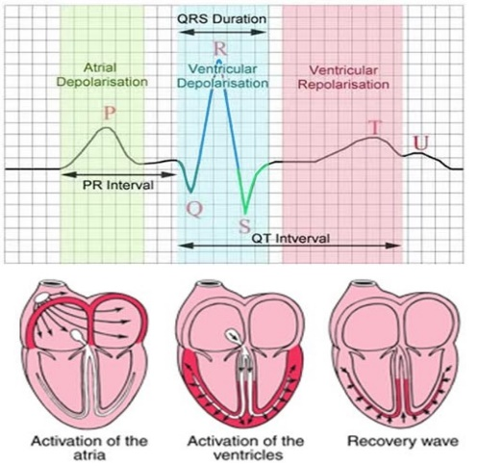

Figure 3 Basic electrophysiology of the heart [12]

### 2.1.3. Encryption of Electronic Protected Health Information (ePHI)

According to the U.S. Department of Human and Health Services (HHS), the privacy rule protects all individually identifiable health information including past, present, or future physical or mental health information held or transmitted in any form or media, whether oral, paper, or electronic, and are called protected health information (PHI). The privacy rule also includes any information that identifies the individual such as name, address, birthdate, or can be used to identify him/her. Encryption of ePHI data is the main way a health organization can qualify data security, that is, data must be in a format in which it is unreadable, unusable, and unpredictable to unauthorized individuals. Medical data encryption experiences some obstacles, for instance, encryption technologies can be extremely complex, implementation can be challenging when dealing with systems where encryption is unsupported, and encrypting solutions require having very specific technical expertise.

Under the Health Insurance Portability and Accountability Act’s (HIPAA) security rule, there are two major implementation standards related to encryption: Encryption and Decryption of electronic protected health information, this standard falls under “Access Control” standard and applies to ePHI only, while Encryption of ePHI whenever thought appropriate falls under “Transmission Security” standard and applies to in-transit ePHI.

## 2.2 Related work

### 2.2.1 Technologies for Connected Health Applications

The integration of sensors, low-power electronics, intelligent computing, and wireless communications is widely used to acquire health-related records using wearable and non-invasive sensors to provide elderlies with remote health monitoring devices to use at home. One major device is the smart walking analyzer; this device uses cheap and low-power consumption sensors that are capable of providing compressed data in real time. These data are utilized in the analysis to classify elderlies by their walking patterns, and relate them to their age and health with high accuracy. Another application is the smart sleeping environment that includes several sensors and actuators. The application includes a check-up form that is used to customize the bedroom according to the sleeper’s needs, such that it senses room and body temperature, humidity, oxygen levels, aroma, brightness, and sound, then use different actuators to adjust these levels, and ensure a peaceful environment for sleeping. Additionally, smart joint monitors are developed using temperature and force sensors, a gyroscope, a wireless transceiver, and multiple accelerometers that are placed at different locations of the knee down to the foot, all shaped in a wearable device. Using these components the device can distinguish physical problems with the knee and report them, follow up with the patient in their exercises at recommended times and frequency, and check if the range of knee movement is in the recommended range [14].

### 2.2.2 Fall Detection Using Various Technologies

Over the past few years, researchers’ attention to the importance of falling detection application increased. Thus, various technologies and algorithms were deployed to compete for proposing the best solution that provides high accuracy and scalability, at minimum size and cost. Figure 4 illustrates various approaches used for fall detection, divided into three categories according to the technologies used. The three focal categories are: wearable sensors, ambient device, and vision based falling detectors, the figure also illustrates several examples of each of these categories as follows:

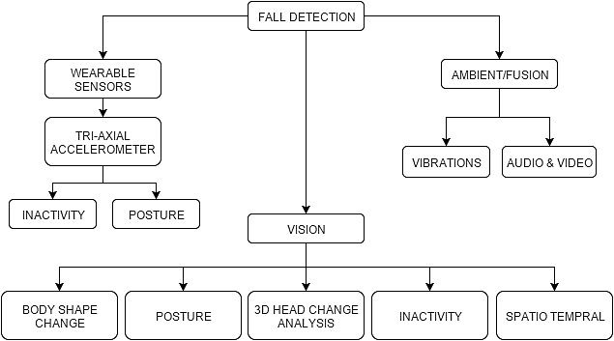

Figure 4 Classification of falling detection method [15]

##### **2.2.2.1 Vision based falling detection**

The proposed system in [16] for elderly living alone at home was developed to resolve the lack of safety elderly might face in a fall situation. This system is consisting of multiple cameras network that reconstructs a three-dimensional (3D) of the human body. Whenever there is a fall event, it is detected, and the volume distribution along the vertical axis is analyzed. If an important part of this distribution is abnormally near the floor for a specified period, an alarm is triggered indicating that this person has fallen on the floor. 24 different scenarios that include 22 fall events, and the system validated 24 activities of daily life (ADL) events. The system achieved 99.7% sensitivity. The real-time implementation using a graphical processing unit (GPU) reached ten frames per second (fps) with eight cameras, and 16 fps with three cameras.

Since elderly are more likely to experience falling accidents that other age groups, particular attention needs to be considered. Nurses or surveillance systems are two options. In the case of the monitoring systems, some can use special sensors as in [17], and others deploy monitoring systems as in [7] and [8]. In [18], an Omni camera was used to detect falling events. A new approach was proposed in [19] in which a MapCam (Omni camera) is used along with the personal information of each being captured on the camera. The system works as follows: The camera captures 360 degrees scene simultaneously and eliminates any blind spot. The personal information which is previously saved for each individual is combined with the system. That information includes weight, height and electronic health history; the system is then adjusted to handle each case on its own by putting more attention to the elderly with extraordinary conditions or diseases. After experiments, the results showed an increased rate of detection when using the personal information with a percentage of 79.8%, and 68% when not using personal information.

##### **2.2.2.2 Ambient Device Based Falling Detection**

Ambience-based devices endeavor to fuse audio and visual data, and sense through vibrating data. Image and video sensing can be achieved using multiple approaches: one method is by bringing the user to the network via wireless node that is used for fall detection by specific event sensing functions, which uses signal strength measurements to track the estimated location of the user. Also, it allows monitoring control to communicate with the user to alert problems [15]. Another method is by extracting wavelet-based features from the raw sensor and apply them to a TEO-based sound activity detector. Also, passive infrared sensors output are processed, and various human and pet motion recordings are used to train the Hidden Markov models resulting from different activities including falling. This procedure is fused together to conclude an ultimate decision [20]. On the other hand, event sensing can be achieved using vibrational data for localization, tracking, and monitoring using a special piezoelectric sensor placed on the floor. Through monitoring floor vibration patterns that are generated by human, the system will process them to be able to distinguish human falls from normal activities, like walking as shown in Figure 5 [21].

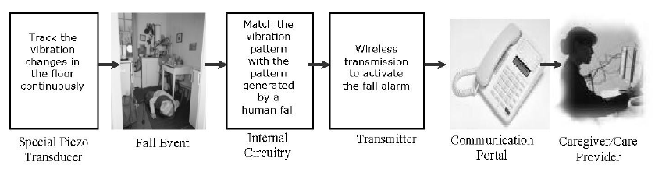

Figure 5 Schematic representation of the working principle of the floor vibration based falling detector [21]

Ambiance device based methods use pressure sensors for object detection enormously. These sensors are based on sensing the high pressure of the object resulting from its weight. They have multiple advantages including cost efficiency and intrusive implementation loss. Conversely, they have a significant disadvantage of sensing everything surrounding the object, which increases false alarms and thus, low accuracy of detection [15]. Figure 6 shows the framework for existing ambiance based approaches.

Figure 6 Framework for existing ambiance based approaches [15]

##### **2.2.2.3 Wearable Device Based Falling Detection**

Wearable devices are divided into two categories: motion based and posture based devices [15]. There are numerous kinds of detection methods that are based on following [22]:

* Motion sensing method using an accelerometer
* Location sensing method using both accelerometer and gyroscope

This approach uses sixMTw sensors, where each unit contains three tri-axial devices: accelerometer, magnetometer, and gyroscope. Each unit records acceleration, the strength of Earth’s magnetic field, and the rate of a turn along three perpendicular axes. After that, these measurements are transmitted over a radio frequency. There are thirty-six different experiments done, some of them for fall actions and the others are for non-fall actions. This approach uses six classifiers to distinguish between fall and ADLs based on machine learning techniques, which achieved an accuracy level above 95%. The KNN and LSM methods do not miss any fall as a result of that they consider it as reliable classifiers. The main shortcoming of this approach is the number of sensors used for calculating the data [23].

In [22], the fall detection system uses a wearable device of a single tri-axial accelerometer and an algorithm that is based on thresholds of summing acceleration and rotation angle information. The summation acceleration is used as the first step to distinguish between high-intensity movements from others. Because some regular motions also produce peak values such as jumping, an additional feature is added to the system, which is an angle calculated based on acceleration measurements. The rotation angle of gravity can be calculated by separating the gravity components before and after human’s fall. The gravity and Coordinate before and after the fall shown in figure7.

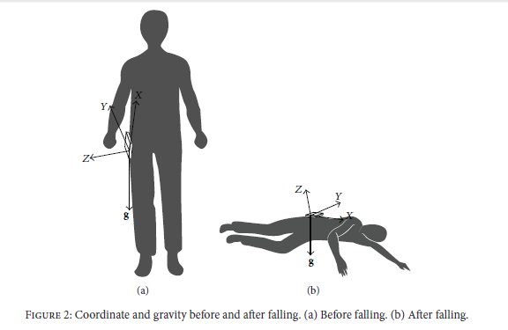

Figure 7 Coordinate and gravity before and after falling. (a) Before falling (b) After falling [22]

This paper [24] uses both accelerometer and gyroscope for building a system for fall detection. The human activities are divided into two categories static postures and dynamic transitions. The system uses two TEMPO accelerometers which are placed in two different locations of the body. Thus, the system can distinguish four kinds of static postures: sitting, lying, standing and bending. Linear acceleration and angular velocity are measured and compared with a particular threshold to determine whether motion transitions are intentional or not. If the change from a lying position is not intentional, a fall event is detected. The sensitivity of this algorithm is 91%, and the specificity is 92%.

This system [25] uses a wearable camera and an accelerometer for fall detection. It combines gradient local binary pattern features with edge orientation histograms to provide higher sensitivity. A simplified form of this algorithm is implemented on an android mobile. The accelerometer data are fused with computed features from camera modality. As a result, a significant decrease in the false alarm was noticed during daily activities. Figures 8 and 9 show how the smartphone is attached to the user, and how sample frames are captured during the fall.

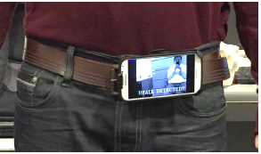

Figure 8 Android smartphone attached to the waist [25]

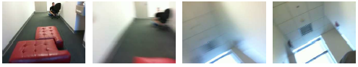

Figure 9 Sample frames captured during a fall from standing up position [25]

##### **2.2.2.4 Summary**

The table below summarizes the previously explained falling detection techniques and illustrates a comparison between different approaches in terms of cost, intrusion, accuracy, setup, and robustness.

Table 1 Summary comparison between various falling detection approaches

|  |  |  |  |  |  |  |
| --- | --- | --- | --- | --- | --- | --- |
| Approach | Category | Cost | Intrusion | Accuracy | Setup | Robust |
| Vision-based | 3D head change [19] | Medium | Low/dependent | Higher/nonspecific | Medium | Yes |
| Body shape change | Medium | Low/dependent | Higher/nonspecific | Medium | Yes |
| Ambient | Audio [18] | Cheap to medium | Yes | Scenario dependent | Easy/medium | No |
| Video  [23][24] | Cheap to medium | Yes | Scenario dependent | Easy/medium | No |
| Wearable devices | Tri-axial [25] | Cheap | Yes | Scenario dependent | Easy | No |
| Inactivity | Cheap | Yes | Scenario dependent | Easy | No |

Figure 10 summarizes the previously mentioned related work for falling detection.

**2009**

**2012**

**2015**

"Measutring gait using a ground laser range sen

Accurate Fast Fall Detection Using Gyroscopes and accelerometer derived posture information"

Q. Li, J. Stankovic, M. Hanson, A. Barth and B. Lach [27]

"

"Design and implementation of fall detection system using compressive sensing and shimmer technology"

H. Rabah, A. Amira and A. A. [19]

"Measutring gait using a ground lasernge sensor,"

"Fall Detection on Embedded Platform Using Kinect and Wireless Accelerometer"

M. Kepski and B. Kwolek [20]

"Measutring gait using a ground laser range sensor,"

"Development of a Wearable-Sensor-Based Fall Detection System,"

F. Wu, H. Zhao, Y. Zhao and H. Zhong [25]

"

"Detecting Falls with Wearable Sensors Using Machine Learning Techniques,"

A. T. Ozdemir and B. Barshan [26]

**2014**

"Measutring gait using a ground laser range sensor,"

"Development of a Wearable-Sensor-Based Fall Detection System,"

F. Wu, H. Zhao, Y. Zhao and H. Zhong [25]

Figure 10 Survey on fall detection using various technologies

### 2.2.3 ECG Acquisition and Analysis

##### **2.2.3.1 Automated ECG delineation using KNN classification**

Automated electrocardiogram delineation system aims to detect reliably and extract the fundamental ECG components; P-duration, PR-interval, QT-interval, and QRS-duration. One approach is using the supervised machine learning algorithm; K-nearest neighbor (KNN), essentially by finding the exact location of the main reference points, that is, onset and offset points of P, QRS, and T-waves. The main method used in [26] is first to acquire and condition ECG signals by passing the signals through a band-pass filter, which reduce the influence of muscle noise, baseline wander, and T-wave interferences. Then, the slope of the signal is calculated and used as a feature vector, used afterward for KNN classifier training. If the training set belongs to QRS region, the label is set to 1, otherwise -1. The system is then tested, and a train of 1’s is obtained at the output of the classifier, and pulse duration of it is averaged. If the length of the train is more than the average, it is classified as QRS-complex and removed from ECG signal whereas others are discarded. Similarly, the ECG signal is trained and tested for P and T-waves.

##### **2.2.3.2 Analyzing ECG signals for different heart ailments**

ECG sensor measures cardiac electrical signals resulting from muscle contractions regarding voltages; these sensors are placed on the five auscultation areas: mitral valve area, pulmonary area, aortic area, secondary aortic area, and tricuspid area. In [27] this kind of sensors were used to acquire ECG signals and analyze them to detect cardiac diseases. Each heart disease has specific characteristics in its ECG waveform response weather in amplitude level or time interval. For instance, for right atrial enlargement, P-wave height exceeds 2.5mm, whereas, for left atrial enlargement, P-wave width exceeds 0.08s. As a result, by extracting the fundamental components and compare them to the predefined features, the system will be able to distinguish between healthy and diseased heart, identify heart ailment, and notify the doctor through mail attaching ECG report. The hard system diagram shows in figure 11.

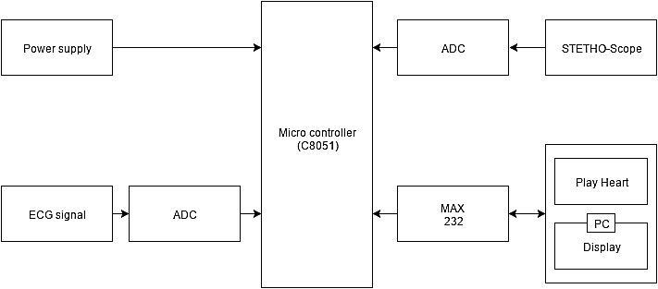

Figure 11 Hardware System Diagram[27]

### 2.2.4 FPGA device based connected health systems

##### **2.2.4.1 FPGA Device Based ECG Monitoring Systems**

Telemedicine is now having a great impact in patients monitoring which are located in non-clinical environments such homes and elder communities. Thus, real-time systems have to be adapted to provide a fast response by the doctor who captures the patient’s information instantly and remotely make a diagnose, and provide an immediate assistance when needed. Such real-time systems can be entirely implemented using Field Programmable Gate Array (FPGA) that is known for its fast manufacturing turnaround time, low power consumption and ease of design changes. A system based on Spartan-3 XC3S400-4TQ144C FPGA is proposed in [28] that centralizes its primary processing as well as the digital filtering and data compression arithmetic on the FPGA device itself. This system acquires real-time ECG signals, amplifies and filters the signal, compresses it for storage and then transmits the signal to the main computer. The system showed advantages as high integration density, powerful functionality, low cost and convenience to carry around. A similar proposed system for ECG monitoring in [29] uses a different approach; a Cheetah ARM SoC platform featuring an FPGA was used, this system provides an on-demand wireless data transmission of ECG signals to a terminal device, and it performs a time-frequency HRV analysis on the acquired signals. This system can be used in personal and healthcare applications to provide an inexpensive, portable and immediate reaction for real-time ECG signals.

Further work has been employed in [30] to diagnose and classify ECG signals in normal, atrial flutter and ventricular tachycardia conditions. Particle Swarm Optimization (PSO) and Artificial Neural Networks ANN were used for beat classification. The system was designed using VHDL on FPGA-Spartan 6 evaluation board, and the system showed, and effectiveness reached to 100%.

Figure 12 summarizes the previously mentioned related work for ECG acquisition and analysis systems.

**2007**

**2013**

**2015**

"Measutring gait using a ground laser range sensor,"

"Real-Time ECG Monitoring System Based on FPGA"

Y. Yang, X. Huang and X. Yu [31]

"

"ECG Signal Diagnoses Using Intelligent Systems Based on FPGA"

H. Akkar and A. Kareem [33]

"Measutring gait using a ground laser range sensor,"

"A Novel Wireless Biomedical Monitoring System with Dedicated FPGA-based ECG Processor"

K. Ravinder, M. Irfan-ur-Rahman, M. W. Hussain and M. Abdul Khader [32]

"Measutring gait using a ground laser range sensor,"

“Acquiring ECG Signals and Analyzing For Different Heart Ailments”

B. Sravanthi, C. Sechukumar and G. Anusha [30]

"

"Automated ECG Delineation using Machine Learning Algorithms"

I. Saini, D. Singh and A. Khosla [29]

**2014**

Figure 12 Survey on ECG acquisition and analysis systems

##### **2.2.4.1 Falling Detection on Heterogeneous Computing Platforms**

A fall detection application on a heterogeneous computing platform, Zynq- 7000 SoC was deployed in [31]. The proposed solution in this system aims to use the power of the ARM Cortex A9 processor of the Zynq platform together with the OpenCV libraries to achieve an efficient solution regarding power consumption and execution time of the fall detection algorithm deployed in the system. The system design will be partitioned between the Field Programmable Gate Array (FPGA) existing in the Zynq SoC, the Cortex A9 processor and the Graphical Processing Unit’s (GPU) that will also be deployed for computer vision. In this study, the power consumption and the execution time of the fall detection implementation were extracted by first using the ARM processor of the Zynq SoC and then decide on the modules that will take the most execution time of the fall detection application and then implement it on hardware (on FPGA). After performing several test and evaluation them, the software implementation of the system showed and average accuracy of 80% under different testing conditions. For the hardware part which implemented a Sobel filter, and some measurement of the power consumption, execution time, and energy were estimated by using Vivado High-Level Synthesis tool (HLS). The conclusion of this system design suggests employing HW/SW co-design to take advantages of the FPGA features which accelerates digital signals processing algorithms and performs effectively in image processing.

Further, similar heterogeneous systems were also developed according to Driessen in [32], as a combination of embedded processors and customized accelerators on heterogeneous computing platform – Zynq 7000 programmable system-on-chip (SOC) were used. The Zynq SoC combines both great embedded processor with field programmable gate array (FPGA) reconfigurable logic. Another system was implemented on Terasic’s DE2- 115 development board including Altera Cyclone IV (EP4CE115) FPGA device, a 5 megapixels CMOS camera sensor and an LCD touch panel. This system was designed taking the most advantage of the parallel and pipeline architecture of the FPGA [33]. Moreover, Shimmer technology with orthogonal matching pursuit (OMP) algorithm was shown in [34]. This system was implemented on Vertix-5 and Zynq 7 platform using Vivado (HLS).

Figure 13 summarizes the previously mentioned related work for fall detection on Heterogeneous Systems.

**2009**

**2014**

**2015**

"Measutring gait using a ground laser range sensor,"

"Measuring gait using a ground laser range sensor"

P. Teixido and J. Palacan [36]

"

A method for automatic fall detection of elderly people using floor vibrations and sound-proof of concept”

Y. Zigel, D. Litvak and I. Gannot [37]

"Measutring gait using a ground laser range sensor,"

"Fall Detection Application on an ARM and FPGA Heterogeneous Computing Platform"

H. T. K. Nguyen, C. Belleudy and P. Van Tuan [34]

"Measutring gait using a ground laser range sensor,"

"Throughput Exploration and Optimization of a Consumer Camera Interface for a Reconfigurable Platform"

F. Driessen [35]

Figure 13 Survey on fall detection on Heterogeneous Systems

### 2.2.5 Using Classification Algorithms with Medical Datasets

Classification algorithms which are categorized as a supervised model, are very powerful tools for pattern recognition, data mining, machine learning, and another data analysis applications. They work by mapping a data item into one of predefined classes, this process is performed in two steps: Building the classification model, and Classification. First, a classification model is constructed to describe a predetermined set of data; this data is divided into two or more classes based on the behavior of the data, or the nature of the system. Then, this data is trained, and a percentage is conducted for testing with the newly entered sample. As a result, classification techniques are considered fast, and accurate comparing with other decision-making techniques such as thresholding. Since the accuracy of medical systems is very critical, engineers tend to use classification algorithms to implement connected health systems. One approach to achieve accuracy for classifying medical datasets is employed in [35]. It is based on KNN and Fuzzy K-nearest neighbors. Weighted nearest neighbors and fuzzy k-nearest neighbors algorithms are used to classify some medical datasets. The difference between any two examples is calculated with several distance functions. The algorithms are tested using four different medical datasets. The fuzzy-KNN takes longest classification time whereas the KNN take the smallest classification time. The fuzzy-KNN was improved using fuzzy entropy that modified increased the accuracy classification. Other research used five different real-world datasets used five supervised machine-learning. This study focuses on the capabilities and inadequacies under certain conditions to help health researcher choosing suitable classifier. The better overall performance goes to a decision tree classifier whereas NB and SVM show stable performance with datasets that contain binary attributes. MLP, SVM and DT training time are proportional to the number of attributes.

# Requirements Analysis

## Functional Requirements

**Target users:**

This project is designed for elderly users who live in their houses, by themselves, or in isolated villages far from hospitals and clinics, to monitor them and detect if any falls have occurred. It also can be used with any user with disabilities, muscular diseases such as poliomyelitis, muscle atrophy, or myasthenia gravis, nervous diseases like Parkinson’s disease, cardiovascular diseases, or even diabetes. Additionally, the system acquires and analyzes ECG signals, then attach them to the medical log when a fall happens. The system can be utilized as a standalone monitoring device at home.

**User’s site:**

At the user’s site, two main hardware components will be present. The user will not control or adjust any of these elements. Rather, the user will only have to wear the Shimmer sensor, and the Zynq SoC prototyping board will be in a fixed place to do the signals processing. The following are the functionalities that the two hardware components are used for:

* Shimmer device

1. Acquire wireless signals using the 3-axial accelerometer in the shimmer device, used for fall detection, and fall positioning.
2. Acquire electrocardiography signals (ECG) that are encrypted to be sent to the patient monitor and decrypt them on the monitor site.

* Zynq SoC board functionalities

1. Perform classification algorithms on input signals:

* Fall detection algorithm based on analyzing the 3-axial accelerometer signals.
* Fall orientation algorithm to specify the position of the fall, and hence, provide an idea of the affected organ.

1. ECG encryption

**Monitoring site:**

The monitoring site will only have one hardware component: a host computer, such that if an alerting email is received, the doctor will be able to receive and decrypt the ECG signal and the extracted features using a simple program. In case the doctor is not around a host computer, he/she can still receive the fall alert and the related information via email.

* Host computer functionality - ECG decryption

Once a fall has been detected, the ECG signals acquired and the extracted features will be first encrypted and then sent to the doctor via email. With the present of a host computer, at the doctor’s office or the ambulance, the information can be extracted easily for visualizing.

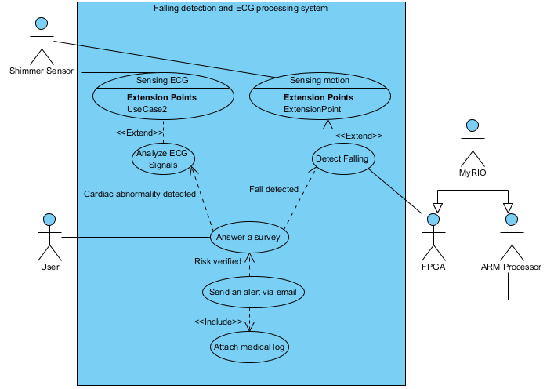

Figure 14 System use case diagram

The explanation of each use case is shown in Table 2.

Table 2 Use cases description

|  |  |
| --- | --- |
| Use case | Brief description |
| Sensing motion | Shimmer device senses movement using built-in tri-axial accelerometer |
| Sensing ECG | Shimmer device senses electrocardiogram signals |
| Analyze ECG Signals | ECG filtering and processing to extract feature |
| Detect falling | Algorithms are applied to detect |
| Answer a survey | If a fall is detected, the system asks simple questions to ensure a fall has happened and ensure elderly’s consciousness. |
| Send an alert via email | An email is sent to the doctor, with details of the fall. |
| Attach medical log | ECG signals are appended to the email to be sent. |

## Design Constraints

Table 3 Technical design constraints

|  |  |
| --- | --- |
| Name | Description |
| Coverage Area | The elderly should not exceed the maximum distance (20 meters) from Bluetooth communication between the Shimmer device and the Zynq SoC board. Since the system is designed for indoor application or in ambulances, this distance is sufficient. |
| Data Transmission (latency) | The transmission time for signals between the Shimmer sensor and the Zynq SoC board should be minimal. |
| Real-time Performance | Falls should be detected in real-time, and the delay should be minimal, typically few seconds. |
| Continuous Monitoring | Battery life of the Shimmer device should be long enough, at least few hours of monitoring. |
| Accuracy | The system has to provide a high percentage of detections, greater than 95% |
| Quality of Data | Acquired signals including acceleration and ECG have to be of high quality such that the signals are recent and the signal-to-noise ratio is maximal. |

Table 4 Practical design constraints

|  |  |  |
| --- | --- | --- |
| Type | Name | Description |
| Economic | Cost | The total cost of the project should not exceed 5000 Qatari Riyals since the average salary for house nursing services is around this value and the project aims to provide an affordable home solution. |
| Usability | Simplicity, Learnability  and Satisfaction | The device should be light and comfortable to wear and easy to be used by an elderly with limited technical skills.  The user interface running on the user and the monitoring person’s application must be easy to use. Which means that they do not require technology knowledge and can be used using minimal user configurations. |
| Safety |  | The shimmer device including ECG electrodes should not threaten patient’s health and safety. |
| Sustainability | Reusability | Other developers can add, modify, and reuse this prototype for future development such as adding more algorithms to the system. |
| Physical | Size | The size of sensing device should be as small as possible to be easily attached to the body. |
| Weight | The sensor should have a lightweight (few grams) to be held by user. |

## Design Standards

Table 5 Design standards

|  |  |  |
| --- | --- | --- |
| Name |  | Description |
| Bluetooth | IEEE 802.15.1 | The shimmer device used to acquire the signals will connect to the myRIO board that will process these signals via Bluetooth connection. |
| Wi-Fi | IEEE 802.11 | The myRIO board will send an email when a fall is detected, with the details of both fall and patient’s health status. This process is done via a Wi-Fi connection. |
| Simple Mail Transfer Protocol (SMTP) |  | The protocol for mail sending and receiving is SMTP using port 587 where connections are secured by SSL. |
| Advanced Encryption Standard (AES) | FIPS PUB 197 | When an alert is sent to the doctor, the email includes user’s ECG signal and extracted features. This information is encrypted using the AES before being transmitted. |

## Professional Code of Ethics

Table 6 Professional code of ethics

|  |  |  |
| --- | --- | --- |
| IEEE | ACM | Project perspective |
| 1. To improve the understanding of technology; its appropriate application, and potential consequences; | 1. Strive to achieve the highest quality, effectiveness, and dignity in both the process and products of professional work;  2. Improve public understanding of computing and its consequences. | Introducing shimmer and FPGA platforms in elderly healthcare applications will familiarize the audience with technology usage in everyday life, and how importantly it affects our lives. |
| 1. To maintain and improve our technical competence and to undertake technological tasks for others only if qualified by training or experience, or after full disclosure of pertinent limitations; | 1. Be honest and trustworthy; | - Applying the knowledge of computer interfacing and hardware/software co-design to produce this project.  - Research about the use of technologies in the field of healthcare, accelerometers, ECG identification, and data authentication using encryption and decryption.  -Working on this project with our effort and capabilities, and the guidance of our supervisor. |
|  | Contribute to society and human well-being. | * This project will provide users’ with independence and confidence, and thus improve the quality of their lives. * Also, it will ease the job for medical mentors and healthcare crew |
| 1. To seek, accept, and offer honest criticism of technical work, to acknowledge and correct errors, and to credit properly the contributions of others; | 1. Honor property rights including copyrights and patent;  2. Give proper credit for intellectual property. | - Accept criticism of the supervisor, and examiners, and use the comments to improve the design accordingly.  - Citing all resources and previous work that have been used.  - Acknowledging all people that have contributed to the project. |
| 1. To accept responsibility for making decisions consistent with the safety, health, and welfare of the public, and to disclose promptly factors that might endanger the public or the environment; | Avoid harm to others. | - The system is designed with the restriction of guaranteeing users safety. |
| 1. To treat fairly all persons and to engage in acts of discrimination based on race, religion, gender, disability, age, national origin, sexual orientation, gender identify, or gender expression. | Be fair and take action not to discriminate. | - The system is designed to be used and benefits any users who need it, regardless of any factor of race.  - The relationship among project team is based on respect and collaboration. |
|  | 1. Comply with the privacy of others;  2. Honor confidentiality. | - The system is designed such that it guarantees user’s privacy by using different terms of authentication of user’s identity and medical records.  - Also, the identity of collaborated people in data collection and testing will be kept private. |

## Assumptions

The following assumptions have been made for the system to work properly:

1. There is at least one person that is responsible for charging the shimmer device.
2. The elderly or the person who’s in charge for him/her should be aware of the correct way to wear the shimmer sensor.
3. The system is designed to be used in an indoor environment only.
4. The environment should provide internet connectivity all time.
5. In the case of a fall, there should be at least one doctor who’s in charge on the person’s condition to receive the message generated by the system.

# Detailed Design

## Overview

In this project, falling detection and ECG analysis are two major concerns. Thus, the design was implemented in two phases that were combined together to build the overall system. The main aim of this chapter is to document a detailed explanation of the design including the hardware and software selection and implementation. Hence, this section also includes an evaluation of the effect of design choices on the quality attributes. Finally, Section 4.5 discusses how the design constraints were met.

## High-Level Architecture

The overall system consists of three stages; data acquisition using the Shimmer sensor, data process and analysis on the Zynq SoC prototyping board and finally alerting healthcare givers in the case of detecting a fall. The system consists of three hardware parts: The Shimmer wireless healthcare sensing device, the NI myRIO-1900 Zynq SoC prototyping board, and a PmodBT2 UART Bluetooth module. These components will be explained in detail in the following subsections. The overall system high-level architecture is described in figure 15.



Figure 15 High-level architecture

High-level architecture illustrated in Figure 15 is detailed as follows (left to right):

1. Data acquisition:
   1. MMA7260qt 3-axis accelerometer is used to acquire acceleration.
   2. ECG Sensors measure the heart muscle electrical activity.

Both sensors are integrated into the Shimmer sensing device which is placed on the user’s chest. The ECG electrodes are connected to the right arm, left arm, right leg, and left leg from one side, and on the white, black, green, and red channels of the Shimmer from the other end respectively.

1. A Bluetooth module is used to establish a connection between the Shimmer device and the Zynq SoC prototyping board.
2. Through this connection, the signals are transferred via Bluetooth to the Zynq SoC prototyping board using the integrated RN-42 Bluetooth module inside the Shimmer as a sender, and the Bluetooth module as a receiver.
3. Data processing and analysis is performed on the Zynq SoC prototyping board using LabVIEW as a programming software environment.
4. If an abnormality is detected, the alerting system will launch to check if the detection is a false alarm or the user needs help. This system also helps in identifying the state of the user after the fall.
5. Finally, if a fall was ensured to occur, an email will be sent using Wi-Fi with an attached medical report to the health care providers.

## Hardware Design

### Shimmer Platform

#### **Overview**

Shimmer sensing device is the significant component in the system, the word Shimmer stands for Sensing Health with Intelligence, Modularity, Mobility, and Experimental Reusability. As the name suggests, it is a small sensor platform designed to work wirelessly for acquiring signals that can be recorded and transmitted in real time, and it is appropriate for wearable applications. Shimmer3 is the most robust wireless sensor and the latest version of the shimmer platform that boasts a 24 MHz CPU with a precision clock subsystem making it three times faster than previous models. It also gives the best data quality by using the gyroscope, altimeter, magnetometer and the two choices of ultra-low noise or wide range accelerometer. Moreover, shimmer can store data without the need of any device, via memory card slot that supports a MicroSD card. The external view is shown in figure 16 (left), the three axis of acceleration are illustrated, whereas the internal view is shown on the right. Different internal components are referred to as the following:

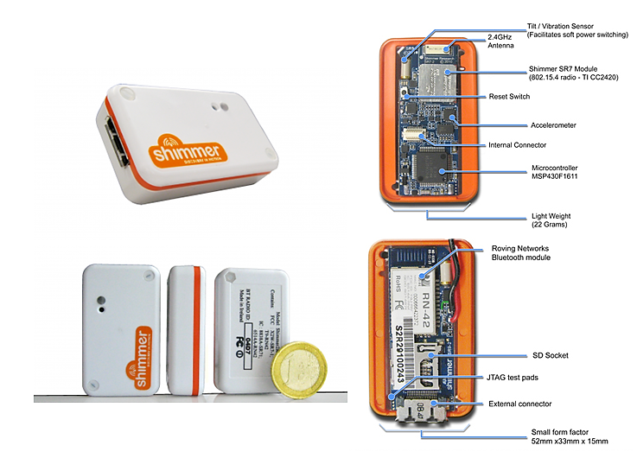

+x

-x

+y

-y

+z

-z

Figure 16 Internal and external views of Shimmer

#### **Shimmer Connections**

Shimmer device has three possible states, Disconnected, Connected and Streaming that can be changed by the Action Command.

* Disconnected: Is the default state in which the Shimmer is disconnected from the system. When the user chooses to connect the Shimmer, it connects to the system with a specified COM port.
* Connected: Is the state when the Shimmer is connected but not streaming any data. During this state, the user can configure the settings of the Shimmer, which includes enabling sensors, setting the frequency rate, and other settings.
* Streaming: Is the state where data acquisition starts and data are streaming in real time from the Shimmer to LabVIEW.

In any of these three states, the user can choose to move from a state to another using button. Below, figure 17 illustrates Shimmer.vi as a state machine and the transition from one state to another.

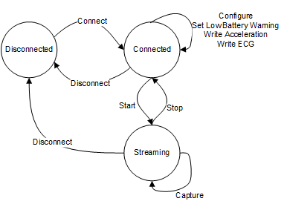

Figure 17 Shimmer.vi as a state machine

#### **Radio Communication**

Shimmer platform communicates via an integrated 2.4 GHz antenna using the Roving Network RN-42 Class 2 Bluetooth module. This module supports the serial port profile and has a full version2 Bluetooth protocol stack that facilitates fast application development. The connection of the module is directly made via UART1 to the MSP430. Moreover, ASCII string over the Bluetooth link is used for controlling the module. The RN-42 supports a distance range of more than 10 meters. The system offers a robust, secure link via frequency hopping spread spectrum (FHSS) and error correction schemes.

To sum up, the Shimmer sensing device was chosen as the main acquisition sensing device due to:

1. It measures acceleration and ECG accurately and produces signals with high signal-to-noise ratios.
2. It integrates Bluetooth module for wireless connectivity.
3. It is small in size and efficiently robust.
4. It is low cost compared with customized sensors with the same capabilities.
5. It has an open-source development platform available for developers.

### Zynq SoC Prototyping Board

#### **4.3.2.1. Xilinx Zedboard**

##### 4.3.2.1.1 Overview

Zedboard is a low-cost development board which is based on the Zynq®-7000 SoC. The board contains all components necessary to create Linux, Android, and Windows designs. This board as any other PC has expansion connectors that enable the users to access the processing system and the programmable I/Os easily. The Zynq SoC platform, which is the major part of the board, combines a dual Corex-A9 PS with 85,000 Series-7 PL cells. One of the vast advantages of the Zedboard is its processor and the 7 series programmable logic that both collaborate to create from simple to powerful and sophisticated designs on the Zedboard. For this project, the algorithms for falling detection and ECG encryption/decryption will be implemented on the Zynq device as IPs [37]. Figure 18 below presents an upper view of the Zedboard.

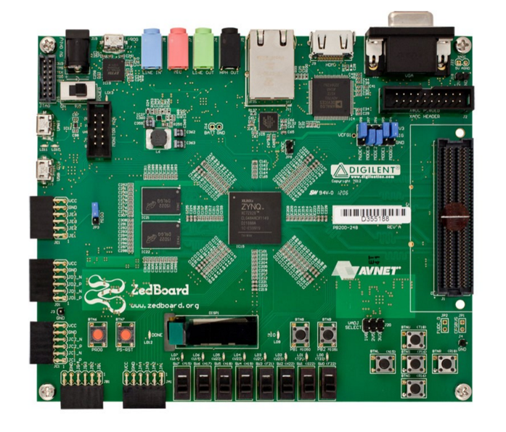

Figure 18 Upper view of the Zedboard [37]

##### 4.3.2.1.2 Block Diagram

As shown in the block diagram, the Zedboard comprises two main subsystems in addition to the Multiplexed I/O (MIO). The two subsystems are part of the Zynq device; the first is the ARM processor system that has integrated memory controllers and peripherals. This processor is completely autonomous to the PL, i.e. it can be used alone and function as a complete PC by itself by running an operating system OS on it and connecting different peripherals like keyboard, mouse, screen to use it as a complete PC. The second part of the Zynq device is the PL which is referred to it as a Field-Programmable Gate Array (FPGA) that is used to extend the processor system. The two system communicate via a high speed advanced eXtendable Interface (AXI). For the board to connect with other peripherals, it features some interfaces as General Purpose Input/ Output (GPIO), Audio Codec, HDMI and VGA for video, Ethernet, SD card slot, FMC interface and other interfaces as shown in Figure 19. In addition to these, the Zynq interfaces to a 256 Mbit flash memory and a 512 DDR3 memory.

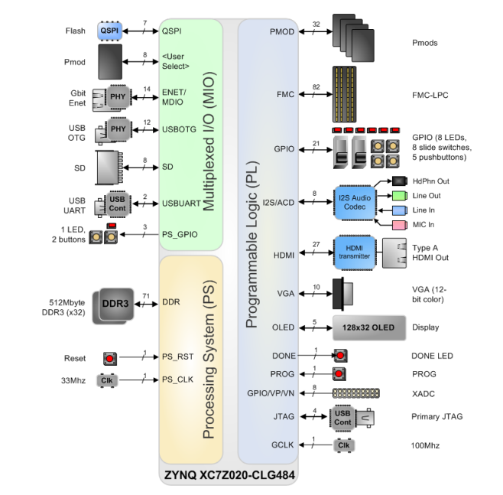

Figure 19 Zedboard hardware block diagram [37]

#### **4.3.2.2. NI myRIO**

NI myRIO, illustrated in Figures 20, 21 and 22 is an embedded hardware device with dual-core ARM® Cortex™-A9 real-time processor and the latest Zynq technology from Xilinx featuring an FPGA customizable I/O, integrated with a processor that runs a real-time OS. Likewise, myRIO provides onboard devices such as an accelerometer, programmable LEDs, audio I/O, analog and digital I/O, and USB port, and it is also possible to connect tens of different external devices. One remarkable feature is the built-in WiFi capability which allows wireless data transfer. NI myRIO couples the power of FPGA programming with LabVIEW software and opts to program the processor with either LabVIEW or C/C++. Moreover, NI myRIO provides the advantage of flexibility and scalability, such that the device can be reconfigured, and the design can be modified, and thus, it provide users with an affordable, flexible and fast to design tool [38].

|  |  |
| --- | --- |
| Figure 20 Front view of the NI MyRIO enclosed device [39] | Figure 21 Upper view of the NI MyRIO inner board [39] |

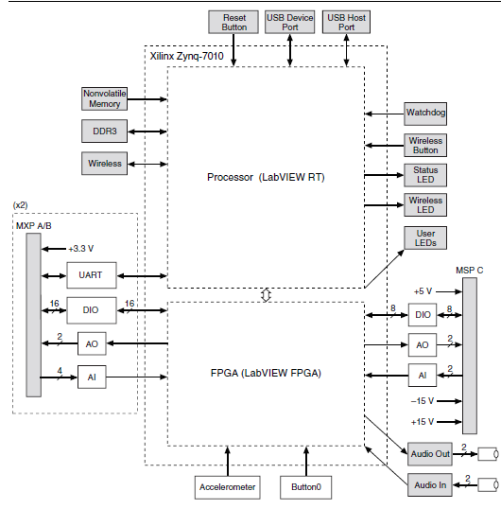

Figure 22 NI myRIO hardware block diagram [39]

#### **4.3.2.3. Xilinx Zedboard vs. NI myRIO**

There are several features for Xilinx Zedboard, and NI MyRIO that would assist the purpose of this project, therefore, a comparison was made between them to decide on the suitable FPGA development board for the system. The below table investigates the pros and cons of each of the boards regarding hardware, processor, memory, resources, features, price, and programming languages to be used. Table 7 shows the comparison between the two prototyping board.

Table 7 Comparison between Zynq SoC prototyping boards; Zedboard and NI-myRio

|  |  |  |
| --- | --- | --- |
|  | Zedboard | NI-myRIO |
| Processor |  | |
| Processor type | Xilinx Zynq-7000 | Xilinx Zynq-7000 |
| Processor speed | 2.5 DMIPS/MHz per CPU | 667 MHz |
| Processor core | Dual -2- | Dual -2- |
| Memory |  | |
| Nonvolatile memory | 256 KB on-chip RAM | 256 MB |
| DDR3 memory | 512 MB | 512 MB |
| Flash memory | 256 MB Quad-SPI Flash | Supports USB Flash drives and USB-to-IDE adapters |
| External memory | 4 GB SD card | Supports SD card |
| FPGA |  | |
| FPGA type | Xilinx 7 series programmable logic equivalent Artix-7 FPGA | Xilinx Zynq-7000 |
| Resources | 85,000 Series-7 Programmable Logic (PL) cells  Audio I/O channels  General purpose input/output lines  Different Input/output peripherals | 28,000 programmable logic cells  10 analog inputs  6 analog outputs  Audio I/O channels  Up to 40 lines of digital input/output (DIO) |
| Board dimensions (in cm) | 16 × 13.5 cm | 13.63 × 8.6 cm |
| Features |  | |
| Bluetooth connectivity | Can establish an IP to establish Bluetooth connection | Bluetooth dongle or module can be connected |
| WiFi connectivity | Must be configured | Built-in WiFi capability with radio mode IEEE 802.11 b,g,n, frequency band of ISM 2.4 GHz, the channel width of 20 MHz, with an outdoor of up to 150m (line of sight). |
| Programming language | VHDL, C/C++ | LabVIEW, C/C++ |
| Price (in U.S. $) | $ 489.99 | $ 324.00 |

On one hand, the design flow of myRIO starts with understanding the system requirements to give a decision about hardware/software design partitioning. Then, the logic is implemented and evaluated on the PC for evaluation. After the design is finalized, it is translated to become FPGA compatible, either using LabVIEW, C/C++, or VHDL generated by LabVIEW. LabVIEW FPGA environment allows performance estimation generation to evaluate the implementation quickly. Optimization may be required to minimize the number of used resources before the system is synthesized. Lastly, a bit stream file is generated, and the project is ready to be used within a top-level LabVIEW FPGA program. The LabVIEW FPGA program can communicate with the software portion implemented on the ARM processor, and finally, the system is integrated to complete the functionality. Figure 23 illustrates the design flow of NI myRIO.

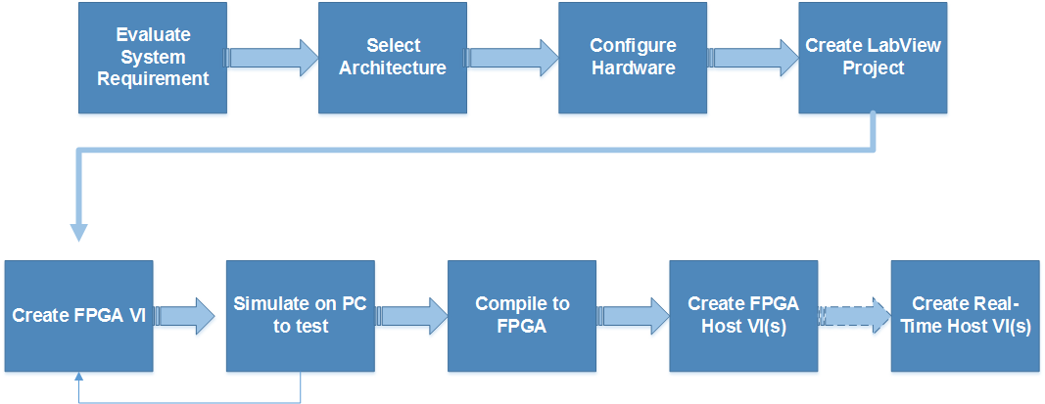

Figure 23 NI MyRIO design flow

One the other hand, Xilinx Zedboard follows the same path of evaluating system requirements and partitioning the functionalities between hardware and software. Typically, software (on the PS) will be used to implement general purpose sequential processing tasks, an operating system, user applications and GUIs, while computationally intensive data flow parts of the design are more suitably realized in the PL. Afterward, the IP integrator is invoked to design the hardware portion, and optimize it using Vivado HLS. Upon completion, the hardware design is exported to Vivado SDK where the software part is implemented. Finally, the hardware and software systems are combined to complete the system functionality. Figure 24 illustrates the design flow of Xilinx Zedboard.

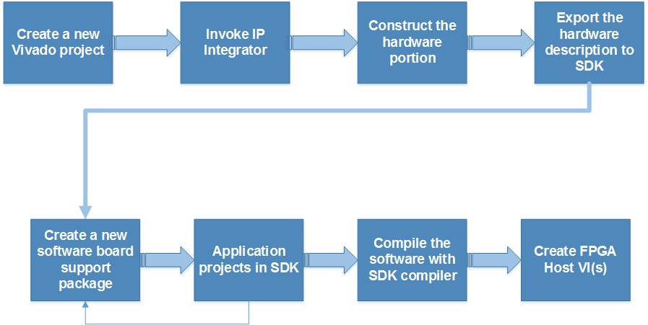

Figure 24 Xilinx Zedboard design flow

In conclusion, myRio board was selected for the following reasons:

1. It has a built-in WiFi capability with radio mode IEEE 802.11.
2. The Bluetooth communication can be established using a Bluetooth module or dongle.
3. It costs only $324 which is low cost compared with Zedboard that costs $489.99.
4. Supports graphical programmability using LabVIEW.
5. It has a smaller size than the Zedboard.

### PmodBT2 Bluetooth module

The PmodBT2 is a peripheral module that employs the Roving Networks RN-42, hence creates a fully integrated Bluetooth interface. This chip allows communicating with it via UART or through the secondary SPI header for updating the RN-42 firmware upon need. PmodBT2 is provided by Diligent Co., which is a National Instruments Company that produces peripheral module interfaces. This means an open standard defined by the company specifically for peripherals used with FPGAs and microcontrollers [40].

The PmodBT2 is configured after it is hard-wired connected to the computer using any terminal software, for instance using puTTY. The configuration can be done only once if the auto-connect mode was selected. Figure 25 illustrates the hardware external view of PmodBT2.

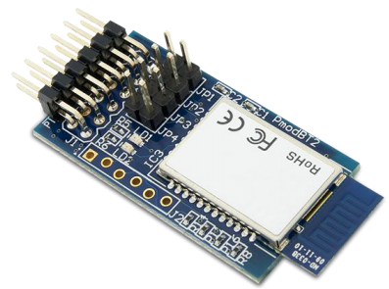

Figure 25 PmodBT2 module [40]

To sum up, the PmodBT2 was selected among other Bluetooth modules due to:

1. It provides six different modes including the master, slave, and auto-connection which allows the module to connect automatically to a predefined device when it is on.
2. It provides secure communication using means of encryption for the transmitted data.
3. It has a 12-pin connector UART interface making it compatible for connecting the NI myRIO device and the SHIMMER sensing device.
4. Features low power consumption.

## Software Design

### Overview of Used Software: LabVIEW

LabVIEW, stands for Laboratory Virtual Instrument Engineering Workbench, is a system design platform and development environment for visual dataflow programming, developed by national instruments. It is used for data acquisition and instrument control and automation. It has many features such as easy interfacing to devices, code compilation, vast and various libraries, parallel programming, ecosystem, specialized forums for technical assistance, and user community which provides low-cost versions for educational institutions. However, LabVIEW has some tradeoffs, for instance, complicated executables of the Application Builder are not standalone as they require LabVIEW run-time engine to be installed on any computer that runs this application. Moreover, LabVIEW tends to produce applications that are slower than if coded by C language. This can be enhanced by using dedicated toolkits for specific operations; LabVIEW makes multi-core programming much simpler and faster than text-based languages.

For this project, LabVIEW is used for developing and testing the entire project in milestones 5-onward and is used with FPGA configuring and programming in myRIO. The following Figure 26 illustrate the design flows in terms of the software used and the programming languages for the NI-myRio.

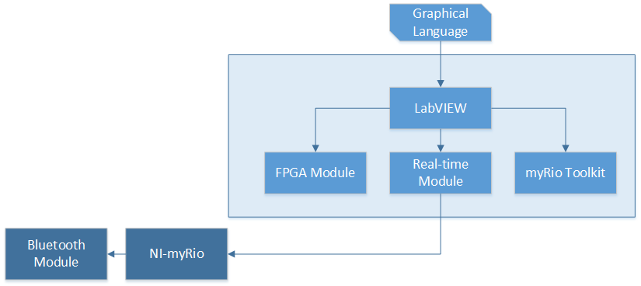

Figure Summary of the design flow using NI myRIO

### Overview of Used Software: Vivado and Xilinx SDK

Vivado design suite proposes a new approach for ultra-high productivity with next-generation C/C++ and IP-based HDL designs, replacing Xilinx ISE with additional features for high-level synthesis and SoC development, such that it represents a ground-up rewrite and rethink of the entire design flow compared to ISE. It is featured as well conceived, tightly integrated, fast, scalable, maintainable, and intuitive, combining all these features in a single software suite compacts the design steps. Vivado supports accelerating the high-level design, for instance, Vivado High-Level Synthesis provides software-defined IP generation, and Vivado IP Integrator allows block-based IP integration. In this project, both Vivado HLS and IP integrator are used to accomplish system’s functionality and implement it on the ZYNQ development board; Zedboard. On the other hand, the Xilinx Software Development Kit (SDK) provides an environment for creating software platforms and applications for Xilinx embedded processors. SDK is based on the Eclipse open-source standard featuring rich C/C++ code editing, compiling, and debugging environment, application build configuration and automatic Makefile generation, and error navigation. The following figure 27 illustrates the design flows in terms of the software used and the programming languages for the Zedboard.

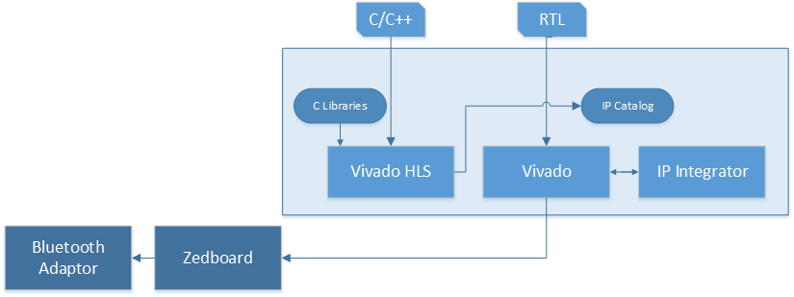

Figure Summary of the design flow using the Zedboard

## Discussion of How Design Constraints Were Met

### Technical Design Constraints

Table Discussion of how technical design constraints were met

|  |  |
| --- | --- |
| Name | Description |
| Coverage Area | The system is mainly used in indoor environments or to equip ambulances with smart solutions, the area between the Shimmer sensor and the Zynq SoC board in the mentioned situations where the system is used will not exceed the Bluetooth coverage area (20 meters). The area was calculated several times and the average value was 19.218 meters. |
| Data Transmission (latency) | Lab experiments including multiple FIFOs in data path have shown a maximum latency of 100ms. |
| Real-time Performance | Falls have to be detected in real-time, and the delay should be minimal. The detection time of the fall was calculated on average to be 5.052 seconds |
| Continuous Monitoring | The design of Shimmer3 sensor supports long-term motion capture that could last up to 2 days using a 3.7V, 450 mAh rechargeable Lithium Polymer battery. The battery life depends on several factors such as which sensor are enabled and he sampling frequency. Since the design utilizes two types of sensors, the Shimmer sensor lasts approximately up to 14 hours which means that the device can charge while the user is asleep. |
| Accuracy | The accuracy of the detections was calculated using the F-value formula to be 96.6% which is greater than the defined value (95%). |
| Quality of Data | The (Collector) block in LabVIEW was used to collect the most recent n samples. Also, the percentage of received and missed packets were also calculated from the extracted information from each packet. The percentage of received packets was much higher than percentage of missed packets. |

### Practical Design Constraints

Table Discussion of how practical design constraints were met

|  |  |  |  |
| --- | --- | --- | --- |
| Type | Name | Description | |
| Economic | Cost | NI-myRio | QR 1179.42 |
| Shimmer3 ECG Unit | QR 1846.22 |
| Roving Networks RN-42 | QR 181.84 |
| **Total:** | QR 3207.48 |
| Usability | Simplicity, Learnability  And Satisfaction | The Shimmer sensor is ultra-weight, weighing only 40 grams and it can be easily worn around the chest using the provided waist strap without any discomfort according to the users’ feedback. The alerting system user interface is simple with visible and clear text. Also, the myRIO prototyping board is small and light, thus, can be placed at home, in the hospital, or in the ambulance. | |
| Safety |  | The fall experiments were done on a mattress with big thickness of approximately 20cm, and the mattress is well-staffed. Several feedbacks were obtained from the users who participated in data collection experiments; they did not feel any harm or discomfort from the electrode pads attached to their skins. However, it is important to mention that the sensor should be removed when defibrillation is attempted since it is not designed with proper safeguards against it. | |
| Sustainability | Reusability | The Zynq SoC prototyping board provides the advantage of flexibility and scalability, such that the device can be reconfigured, and the design can be modified deploying more algorithms. The Shimmer also has other embedded sensors such as the temperature and the pressure sensors which can be used to extend the capabilities of the system. | |
| Physical | Size | The Shimmer sensor features:  1- Ultra-lightweight (31 grams)  2- Compact Dimensions (65 x 32 x 12 mm) | |
| Weight |

# Project plan

## Project Milestones

Table 22 Project milestone

|  |  |  |
| --- | --- | --- |
|  | Description | Deliverable |
| Milestone 1: |  | |
| Project requirements and specifications | * Understand the requirements of the project. * Choose a set of problems and suggested solutions | A list of challenges with the corresponding proposed solutions. |
| Problem statement | * Agree upon a problem, and propose a solution. * Finalize the problem statement | Project abstract |
| Introduction and motivation | * A detailed description of the problem and solution, including technical and non-technical challenges. * Focus on project significance and objectives. | * Introduction and motivation * Project objectives |
| Milestone 2: |  | |
| Background and literature review analysis | * Develop a background to base the project on * Refer to previous work in research papers | * Complete background and literature review analysis |
| System design | * Develop system use case diagram * Agree upon hardware and software to be used for implementation * Agree upon hardware/software partitioning | * System uses case diagram * Hardware/software to be used |
| Milestone 3: |  | |
| Requirement analysis | * Specify functional requirements, design constraints, design standards, professional code of ethics, and project assumptions. | * Detailed requirements analysis |
| Milestone 4: |  | |
| Proposed solution | * Design a high-level architecture of the project * A detailed description of system implementation, including principal components, interfaces, and interaction between them. | * System implementation statement * Updating hardware/software to be used * Updating use-case diagram |
| Milestone 5: |  | |
| Data acquisition and preprocessing | * Develop data acquisition system for Triaxial acceleration and ECG, and signal conditioning * Test the system and build a database | * Data acquisition system * Database |
| Milestone 7: |  | |
| Data processing and algorithm development | * Data storage and retrieval * Apply data classification algorithms and data fusion techniques. | * Falling detection system |
| Milestone 8: |  | |
| Testing and evaluation | * Test and evaluate the system with different cases. | * Update the system to produce more accurate versions |
| Milestone 9: |  | |
| Hardware implementation | * Start to configure the FPGA for the application. |  |
| Milestone 10: |  | |
| Complete final report | * Complete and review the final report | * Update the final report with any change or correction |
| Milestone 11: |  | |
| Prepare final presentation and demonstration | * Prepare the final presentation * Rehearse for the demonstration * Demonstrate the project to the examiners and audience | * Final presentation * Final demonstration and defense. |

## Project Timeline

### Project Timeline of Senior Design Project I

Table 23 Project timeline and work distribution among team members for SDP I

|  |  |  |  |  |  |  |  |  |  |  |  |  |  |  |  |
| --- | --- | --- | --- | --- | --- | --- | --- | --- | --- | --- | --- | --- | --- | --- | --- |
| **Week** | **1** | **2** | **3** | **4** | **5** | **6** | **7** | **8** | **9** | **10** | **11** | **12** | **13** | **14** | **15** |
| **Sep** | | | **Oct** | | | | **Nov** | | | | | **Dec** | | |
| **13** | **20** | **27** | **4** | **11** | **18** | **25** | **1** | **8** | **15** | **22** | **29** | **6** | **13** | **20** |
| **Introduction and motivation** |  |  |  |  |  |  |  |  |  |  |  |  |  |  |  |
| problem statement |  |  |  |  |  |  |  |  |  |  |  |  |  |  |  |
| project significance |  |  |  |  |  |  |  |  |  |  |  |  |  |  |  |
| project objective |  |  |  |  |  |  |  |  |  |  |  |  |  |  |  |
| **Background and literature review analysis** |  |  |  |  |  |  |  |  |  |  |  |  |  |  |  |
| **Background** |  |  |  |  |  |  |  |  |  |  |  |  |  |  |  |
| Acceleration |  |  |  |  |  |  |  |  |  |  |  |  |  |  |  |
| Electrocardiogram (ECG) |  |  |  |  |  |  |  |  |  |  |  |  |  |  |  |
| Encryption of Electronic Protected Health Information |  |  |  |  |  |  |  |  |  |  |  |  |  |  |  |
| **Related work** |  |  |  |  |  |  |  |  |  |  |  |  |  |  |  |
| Using Technologies in Elderly Healthcare Applications |  |  |  |  |  |  |  |  |  |  |  |  |  |  |  |
| Falling detection using various technologies |  |  |  |  |  |  |  |  |  |  |  |  |  |  |  |
| ECG acquisition and analysis |  |  |  |  |  |  |  |  |  |  |  |  |  |  |  |
| FPGA device based falling detection systems |  |  |  |  |  |  |  |  |  |  |  |  |  |  |  |
| **Requirements analysis** |  |  |  |  |  |  |  |  |  |  |  |  |  |  |  |
| Functional requirements |  |  |  |  |  |  |  |  |  |  |  |  |  |  |  |
| Design constraints |  |  |  |  |  |  |  |  |  |  |  |  |  |  |  |
| Professional Code of Ethics |  |  |  |  |  |  |  |  |  |  |  |  |  |  |  |
| Design standards |  |  |  |  |  |  |  |  |  |  |  |  |  |  |  |
| Assumptions |  |  |  |  |  |  |  |  |  |  |  |  |  |  |  |
| **Proposed solution** |  |  |  |  |  |  |  |  |  |  |  |  |  |  |  |
| Solution Overview |  |  |  |  |  |  |  |  |  |  |  |  |  |  |  |
| High-level architecture |  |  |  |  |  |  |  |  |  |  |  |  |  |  |  |
| Hardware/software to be used |  |  |  |  |  |  |  |  |  |  |  |  |  |  |  |
| Shimmer platform |  |  |  |  |  |  |  |  |  |  |  |  |  |  |  |
| Zynq SoC prototyping board |  |  |  |  |  |  |  |  |  |  |  |  |  |  |  |
| Xilinx Zedboard |  |  |  |  |  |  |  |  |  |  |  |  |  |  |  |
| NI myRIO |  |  |  |  |  |  |  |  |  |  |  |  |  |  |  |
| Xilinx Zedboard VS NI myRIO |  |  |  |  |  |  |  |  |  |  |  |  |  |  |  |
| **KNN classifier implementation for fall detection** |  |  |  |  |  |  |  |  |  |  |  |  |  |  |  |
| **Testing** |  |  |  |  |  |  |  |  |  |  |  |  |  |  |  |

### Project Timeline for Senior Design Project II

Table 24 Project timeline and work distribution among team members for SDP II

|  |  |  |  |  |  |  |  |  |  |  |  |  |  |  |  |  |
| --- | --- | --- | --- | --- | --- | --- | --- | --- | --- | --- | --- | --- | --- | --- | --- | --- |
| **Week** | **1** | **2** | **3** | **4** | **5** | **6** | **7** | **8** | **9** | **10** | **11** | **13** | **14** | **15** | **16** | **17** |
| **Feb** | | | **March** | | | | **April** | | | | **May** | | | | |
| **14** | **21** | **28** | **6** | **13** | **20** | **27** | **3** | **10** | **17** | **24** | **1** | **8** | **15** | **22** | **29** |
| * **Data Acquisition** |  |  |  |  |  |  |  |  |  |  |  |  |  |  |  |  |
| 3-axis acceleration |  |  |  |  |  |  |  |  |  |  |  |  |  |  |  |  |
| ECG |  |  |  |  |  |  |  |  |  |  |  |  |  |  |  |  |
| * **Data Processing and Algorithm Development** |  |  |  |  |  |  |  |  |  |  |  |  |  |  |  |  |
| Rebuild the database in time domain |  |  |  |  |  |  |  |  |  |  |  |  |  |  |  |  |
| Testing the fall detection system on LabVIEW |  |  |  |  |  |  |  |  |  |  |  |  |  |  |  |  |
| * **Hardware Implementation** |  |  |  |  |  |  |  |  |  |  |  |  |  |  |  |  |
| Bluetooth connection between Shimmer and the myRIO prototyping board |  |  |  |  |  |  |  |  |  |  |  |  |  |  |  |  |
| Implementation of KNN algorithm for fall detection using LabVIEW/VHDL on the FPGA |  |  |  |  |  |  |  |  |  |  |  |  |  |  |  |  |
| Testing the Fall detection system |  |  |  |  |  |  |  |  |  |  |  |  |  |  |  |  |
| Implementation of ECG encryption/decryption |  |  |  |  |  |  |  |  |  |  |  |  |  |  |  |  |
| * **Testing and evaluation of the integrating system** |  |  |  |  |  |  |  |  |  |  |  |  |  |  |  |  |
| * **Review Final Report** |  |  |  |  |  |  |  |  |  |  |  |  |  |  |  |  |
| * **Prepare Final Presentation** |  |  |  |  |  |  |  |  |  |  |  |  |  |  |  |  |
| * **Demonstration** |  |  |  |  |  |  |  |  |  |  |  |  |  |  |  |  |

## Anticipated Risks

A rigorous risk management approach have been adopted in the entire project to ensure the production of the expected project deliverables. The risk management produced in this project was assisted by the supervisor who had an active role in supervising the integrated work between the various work packages and research activities.

Roles are divided among students, and each is assigned a specific task that were later reported and monitored by the project supervisor through conducting periodic weekly meetings to ensure any critical situations are handled. Necessary actions were taken to try eliminating the effects of any risk, and plans were put to tackle any further technical or managerial issues. To avoid any methodological/technological related hazards: few tests were performed prior to guarantee that the proposed solution in the project meets the requirements of the targeted audiences. As progress is made in this project, further tests were conducted, and the databases was updated to ensure the production of more accurate results. Also, incremental tests were done on different modules used in the project as well as the entire integrated system.

# Delivery

## Real-world deployment scenarios

1- Equip ambulances with smart solutions

Hamad Medical Cooperation (HMC) Ambulance Service is interested in equipping their ambulances with smart solutions for real-time monitoring and data analysis. The ambulance service showed interest in remote monitoring solutions at home, and specifically fall detection and ECG analysis; such system will significantly accelerate their response in emergency situations.

2- Deploying the system in home environments or elderly health-care centers

The system can be set-up at home or elderly health-care centers, where the system will keep monitoring the user’s condition all the time, and if an abnormality occurs, an alerting system will notify the health caregivers or nurses remotely about the user’s situation to provide immediate assistance.

## Commercialization potential and opportunities

The system provides a solution that is reliable, affordable and comfortable solution for elderlies who live alone in their houses or in isolated villages far from hospitals and clinics to monitor them to detect falls have occurred. Moreover, it can be used with any user with disabilities. Additionally, the system acquires and analyzes ECG signals, then attaches them to the medical log when a fall happens. The system can be utilized as a standalone monitoring device at home. Examples of such organizations are Hamad Medical Corporation and ALShafallah center.

# Conclusion

In this project, two main systems were implemented: fall detection and direction system and ECG processing and feature extraction system. Comparison has been done to evaluate the implementation of the KNN algorithm on the PL and the PS in terms of accuracy and execution time. It was concluded that algorithms implementation on the hardware; such as the FPGA results in high accuracy and short execution time among other approaches.

# Future Work

Some suggested improvements are:

* The fall detection can be enhanced to include information about the strength of the fall.
* The system can further be improved to predict falls for extra risk reduction.
* The ECG analysis system can be developed to include heart abnormalities detection and diagnosis.
* The system can further include Acceleration and ECG signals fusion to study the effect of falls on the ECG waveform.
* The fall detetion database can be extended to include personal information that will assist in abnormalities detection and false alarms reduction.
* The system performance can be enhanced by acquiring data from the target audience, then test the system on them.
* The ECG signal and extracted features decryption system can be implemented as a mobile App instead on a host PC to provide mobile monitoring.

# Students Reflection

**Dina’s reflection**

During the senior project I have gained by this experience an exceptional level of knowledge. I had the opportunity to work with a new platform which is the Zynq Soc. I had learned how I can design hardware-software co-design system using the hardware and software inside the Zynq to implement intelligent healthcare system that will help elderly people and human with disabilities. Moreover, the senior design enhances my communication, research, self-learning, time management, and team work skills. Improving these skills will help me in future academic degree and work.

**Hala’s reflection**

The senior project experience was a bit tough and frustrating at sometimes, but it changed many aspects and introduced me to new knowledge and skills. This experience got me discover and learn new capabilities and expertise and use the skills I have gained in my four years journey in college. I was introduced for the first time to the connected-health field and the importance of deploying computer engineering technologies into this area. I have also applied the knowledge gained from some course I have taken earlier, hardware/software co-design for instance, interfacing sensors, developing algorithms and compute its efficiency. This project experience also allowed me to experience different programming platforms (LabVIEW, Vivado and Vivado HLS), various modules (myRio toolkit, FPGA and real-time module) and new approaches in programming. One of the most important things I have actually gained from this project is teamwork skills, adapt to situations, and find solutions to problems efficiently, self-learning and documenting professionally.

**Tasnim’s reflection**

The senior project represented an incredible experience and a great opportunity to bring me to a whole new level of knowledge. This was made possible by pushing me from my comfort zone, requiring me to advance my research skills, communication skills, presentation skills. As well-said, life begins at the end of your comfort zone, and that has always been the case with this specific project. I got to be introduced to the field of connected health for the first time and learn about the different methods in which technology can assist the medical sector, hence improve people’s way of living. On the other hand, the project allowed me to experiment with new platforms, different modules, unfamiliar sensors, various programming environments apart from theoretical concepts, and adapt myself to them in a way that accomplishes the goal. In addition, the senior project enhanced my team work skills, time management skills, and self-learning, which introduced me to the real world experience. Through this project, I aim to continue on the path of research and I am motivated to gain higher academic degrees.